Academic Year: 2025-26 | Year: Second Year | Term: I
Roll No.: 1012411011 | Name: Riddhee Kulkarni
Subject: Java
Assignment No.: 7 | Title: inventory management system
Date: 15/09/2025

AIM:
To implement basic operations (add, remove, iterate) on ArrayList and LinkedList, and perform basic operations on HashSet and TreeSet, including adding/removing elements and checking for duplicates. Apply these operations in context of inventory management system.
THEORY:
An ArrayList in Java is a dynamic array that can grow or shrink as needed. It maintains the order in which elements are inserted and allows duplicate values. Since it is internally backed by an array, accessing elements by index is very fast, but inserting or removing elements in the middle is slower because other elements need to be shifted.
A LinkedList is a data structure made up of nodes where each node stores data and links to the next (and previous) node. It also preserves the order of insertion and allows duplicates. Unlike an ArrayList, it provides faster insertion and deletion at the beginning or middle since it only adjusts links, but accessing an element by index is slower because it must traverse through nodes.
A HashSet is a collection that stores unique elements using hashing. It does not guarantee the order of elements, meaning the order may change as the set grows. Since it uses a hash table, operations like adding, removing, and searching are generally very fast. However, it cannot store duplicate values, making it useful when uniqueness is required.
A TreeSet is a collection that stores unique elements in a sorted order, typically using a balanced tree internally (like a Red-Black tree). This means elements are always arranged in ascending order (natural ordering or a custom comparator). It does not allow duplicates, and while it is slower than a HashSet for operations, it is very useful when you need both uniqueness and sorted data.

FLOWCHART:
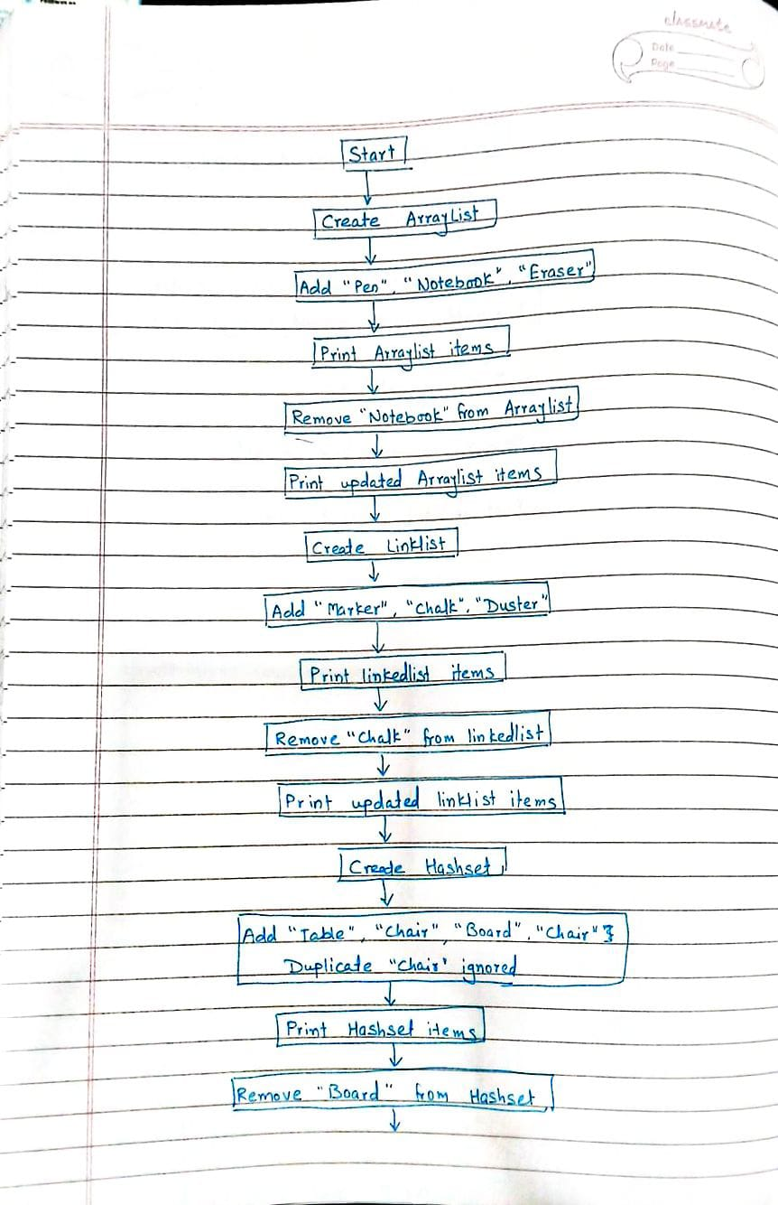
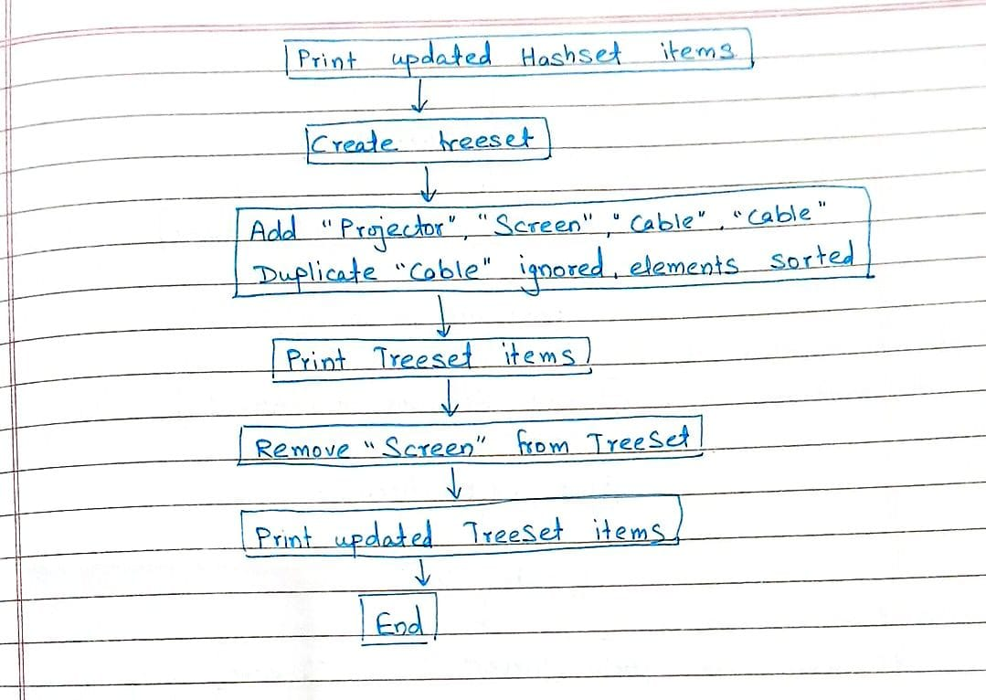

CODE:
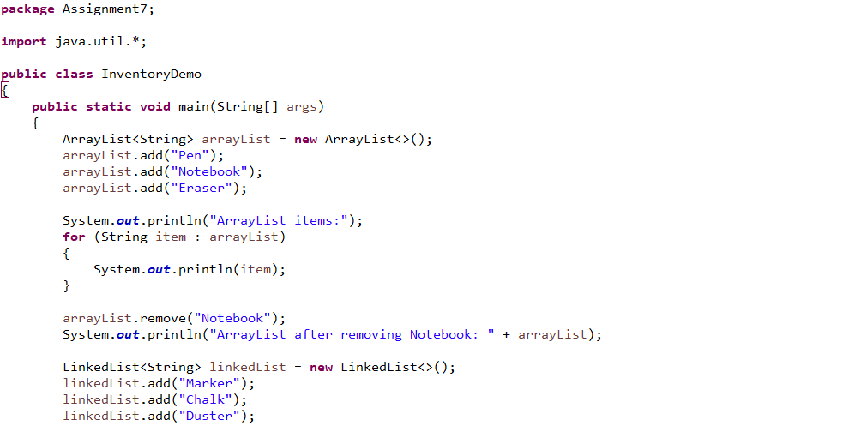
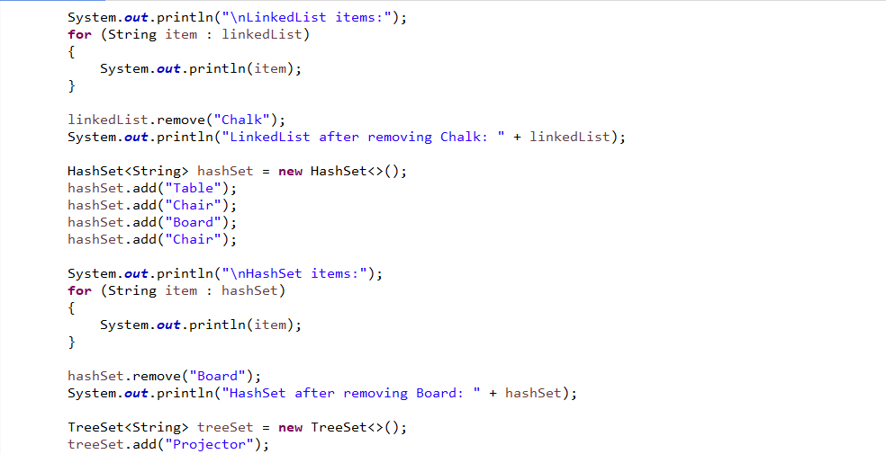
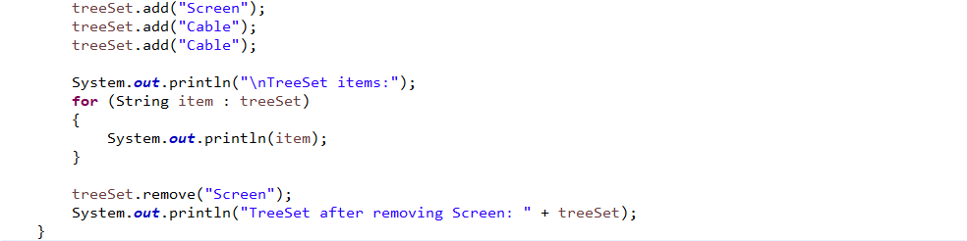

OUTPUT:
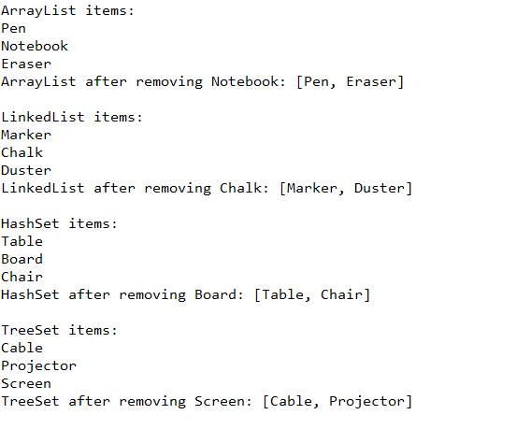

CONCLUSION:
The program illustrates the use of different Java collection classes for inventory management. ArrayList and LinkedList store items in insertion order, while HashSet avoids duplicates without order, and TreeSet maintains both uniqueness and sorting. By performing add, remove, and display operations, the code clearly shows how each collection behaves and how they can be applied for efficient inventory handling.

